SECTION A (60 Marks)
Answer only three questions from this section.
- Complete the following equations and outline the mechanisms.

- Water boils at 100ᵒC and a pressure at 101.3kPa. Aminobenzene boils at 112ᵒC.A mixture of water and aminobenzene boils at 96ᵒC.
- Explain the above observation. (05 marks)
- (i). Define what is meant by the term steam distillation? (01 mark)
(ii).Explain the principle of steam distillation. (04 marks)

- State the requirements for a substance to be isolated by steam distillation. (01½ marks)
- Name one substance apart from aminobenzene that can be isolated by steam distillation. (0½ mark)
- State 2 advantages of steam distillation. (01 mark)
- When compound Y was steam distilled at standard atmospheric pressure, the temperature of distillation was 96ᵒC. The vapour pressure of water at this temperature is 730 mmHg and the distillate contained 74% of water. Calculate the relative molecular mass of Y. (03 marks)
- The vapour pressure of water at 50ᵒC is 92mmHg.A solution containing 18.1g of a non-volatile solute X in 100g of water has a vapour pressure of 87mmHg at the same temperature. Calculate the relative molecular mass of X.
- Calculate the vapour pressure of the solution. (02 marks)
- State and explain the effect of the concentration of the solute on the boiling point of Y. (02 marks)

- 25cm³ of 0.1M ammonia solution was titrated with hydrochloric acid and the pH of the solution was measured at intervals. The table below gives the pH of the solution when measured volumes of hydrochloric acid were added.
Volume of hydrochloric acid (cm³) | 0.0 | 10.0 | 15.0 | 16.5
pH of the solution | 10.20 | 9.08 | 8.30 | 6.70
- (i) Plot a graph of pH against volume of hydrochloric acid. (03 marks)
(ii)Explain the shape of the graph. (05 marks)
(iii)Calculate the molarity of the hydrochloric acid. (03 marks)
- The PH ranges of some indicators are shown below.
Indicators | pH range
Thymol blue | 1.2 - 2.8
Methyl red | 4.8 - 6.0
Phenolphalein | 6.6 - 8.0
Which one of the above indicators is most suitable for the above titration? Explain your answer. (02 marks)
- (i)What is a ‘buffer solution’? (01 mark)
(ii)Explain the working of an alkaline buffer. Use suitable examples to illustrate your answer. (05 marks)
- State 2 uses of buffer solutions. (02 marks)
- (a) (i).Write the outermost electronic configuration of group (IV) elements. (0½ mark)
(ii).State the oxidation states of the elements. (01 mark)
(iii).Explain the trend in the stability of oxidation states. (01½ marks)

- The table below shows atomic numbers and melting points of some group (IV) elements. Explain the trend in melting points. (04 marks)
Elements | ₆C | ₁₄Si | ₃₂Ge | ₈₂Pb
Melting point (ᵒC) | 3,750 | 1,420 | 950 | 327
- Describe the reaction of the elements with:
- Water
- sulphuric acid

SECTION B (40 Marks)
Answer only two questions from this section.
- Explain the following observations. Write equations for the reactions that take place where necessary.
- When a concentrated solution of sodium carbonate is added to a solution of potassium chromium (iii) sulphate (K₂SO₄.Cr₂(SO₄)₃.24H₂O) , a green precipitate is formed with bubbles of a colourless gas. (04½ marks)
- Methanoic acid reacts with ammoniacal silver nitrate solution to form a silver mirror but ethanoic acid does not. (04 marks)
- A solution of sodium thiosulphate becomes cloudy when it is exposed to air for some time. (02 marks)
- When concentrated hydrochloric acid is added to a solution of cobalt (II) chloride, the pink solution turns blue. (02 marks)
- The ionization energy of period (III) elements increase across the period but the first ionization energy of aluminium is lower than that of magnesium and that that of sulphur is lower than that of phosphorus. (05 marks)
- When a solution of manganese (II) chloride is heated with concentrated nitric acid and lead (IV) oxide, the colourless solution turns purple. (02½marks)

- Write equations to show how the following compounds can be synthesized. Indicate the reagents and conditions.

- Phosphorus (V) chloride decomposes when heated according to the equation.
The enthalpies of formation of phosphorus (V) chloride and phosphorus (III) chloride are ⁻398.8 and ⁻306.0 KJ/mole respectively.
- Calculate the enthalpy of dissociation of phosphorus (V) chloride. (02 marks)
- Explain the effect of the following on the position of equilibrium, value of the equilibrium constant and rate of attainment of equilibrium:
- Increasing temperature. (04 marks)
- Increasing pressure. (04 marks)
- Adding a catalyst. (02½ marks)

- Nitrogen monoxide reacts with oxygen according to the equation:
3 moles of nitrogen monoxide and 1.5 moles of oxygen were heated in a 1dm³ closed vessel at 450ºC.at equilibrium the vessel was found to contain 0.5 moles of oxygen.
- Calculate the equilibrium constant at this temperature. (03 marks)
- When the temperature was raised to 600ºC the mixture in (a) was found to contain 25% of the initial nitrogen monoxide. Calculate the equilibrium constant at 600ºC. (02½ marks)
- Deduce whether the reaction is exothermic or endothermic. Explain your answer. (02 marks)

- Describe the industrial manufacture of sulphuric acid starting with iron pyrites. (07½ marks)
- State 2 uses of sulphuric acid (other than manufacture of fertilizers) (01 mark)
- Concentrated sulphuric acid is 98% acid and has a density of 1.84 gcm⁻³.
- Calculate the molar concentration of the acid. (02½ marks)
- Calculate the volume of acid required to prepare 1 litre of 0.2M solution. (02 marks)
- Write an equation to show how sulphuric acid is used to prepare a superphosphate fertilizer. (01 mark)
- Describe the reaction of sulphuric acid with:
- Copper. (02 marks)
- Iron. (04 marks)

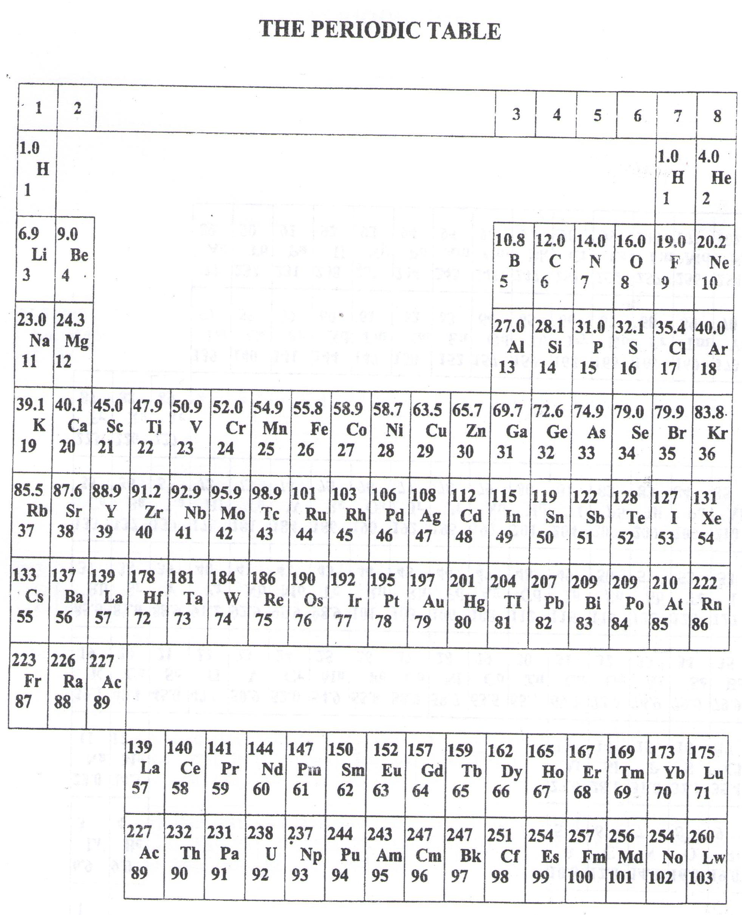

- ===END===
WELCOME TO SENIOR SIX, YEAR 2023
This is the last page of the printed paper, Page 06

